**Orthopaedic Research Grant Digital Communications Content**

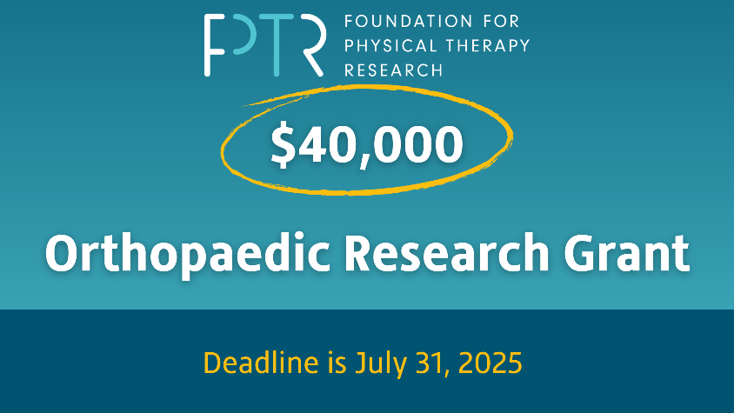

**Applications Now Open for the Foundation’s Orthopaedic Physical Therapy Research Grant**

Applications are now open on ProposalCentral.Com for the 2025 Orthopaedic Research Grant from the Foundation for Physical Therapy Research.

This $40,000 grant supports research that examines clinical outcomes of physical therapy practice for patients with musculoskeletal conditions. Studies must address at least one priority of the [2023 APTA Research Agenda](https://www.apta.org/patient-care/evidence-based-practice-resources/research-agenda-physical-therapy-from-apta). Applicants must be licensed physical therapists or physical therapist assistants and members of the APTA Academy of Orthopaedic Physical Therapy.

This grant is generously supported with funds from the APTA Academy of Orthopaedic Physical Therapy Endowment Fund, which has supported orthopedic physical therapy research since it was originally established by the academy in 2006.

Updated [guidelines](https://foundation4pt.org/wp-content/uploads/2025/04/2025-Ortho-PT-Research-Grant_Apr15_FINAL.pdf) and [instructions](https://foundation4pt.org/wp-content/uploads/2025/04/Orthopaedic_RG-Application-Instructions_2025_Apr18_FINAL.pdf) for this research grant can be found on our website. All guidelines have been reviewed, and changes have been made. Instructions will reflect changes to the application form and templates. The instructions also explain how to find the application form on ProposalCentral.com.

For a full list of six grants that are open for application, please click [here](https://foundation4pt.org/grants/). If you are interested in applying for any of these grants, we encourage you to [sign up](https://url.us.m.mimecastprotect.com/s/pRMfCyP7lxT7D9YOHAuJcxByvb?domain=eml-pusa01.app.blackbaud.net) for the Foundation’s research grant mailing list to receive emailed FAQs updates with clarifications about and notices of any changes to the application form during the application period.

**The deadline submission for all research grant applications is July 31 at 5:00 p.m. EDT.**