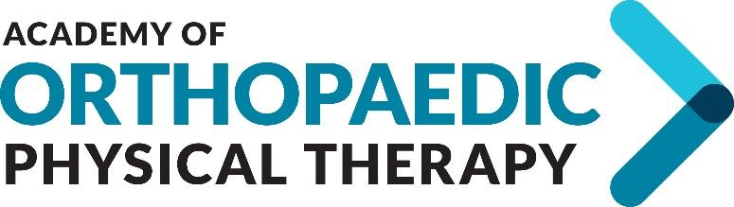

Potential Candidate Form - INCUMBENT

INSTRUCTIONS: The Academy of Orthopaedic Physical Therapy’s Nominating Committee is seeking recommendations for the 2021 Slate of Candidates. If you are currently serving on the Academy Board and have been recommended for re-election, please complete this form. Type your answers and email them, along with all requested materials to tfred@orthopt.org on or before May 31, 2021. This information will be viewed by the Academy’s Nominating Committee in an effort to assist them in getting to know potential candidates better. Please keep your responses brief. If you have any questions, please contact tfred@orthopt.org.

- Why do you want to continue serving in your current role?

- How have you used your experience, talents, and skills in the role for which you are currently serving, and what was the outcome/results?

- When you are part of a group or team, what are your strategies to help the team build consensus on a decision that cannot be agreed upon? Please include an example

Attachments:
- Photo: Please include an electronic photo of yourself. This photo will be placed on the slate of candidates if you are slated.

- Resume: Please include a resume/CV as a separate document.

